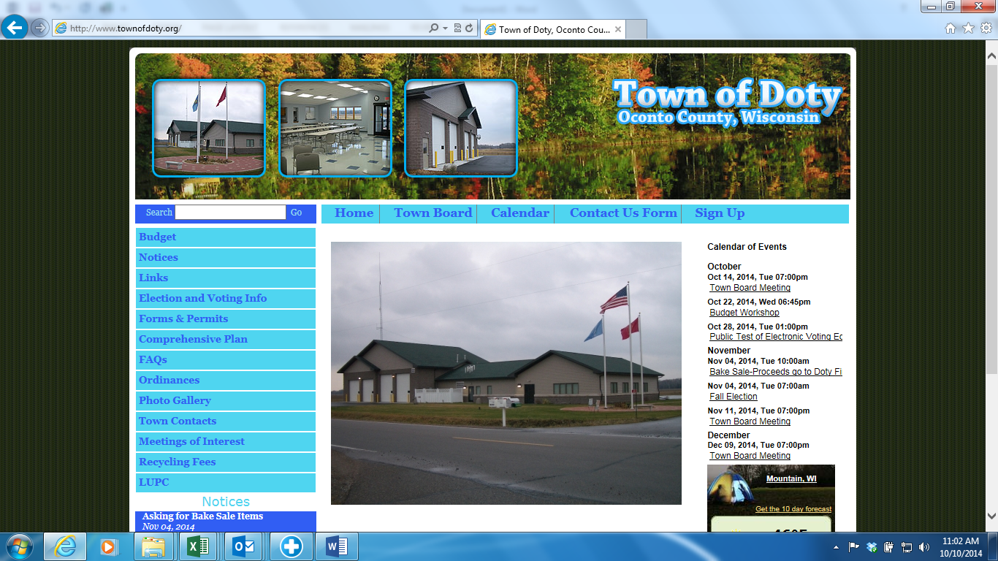

**AGENDA – Public Hearing; Special Meeting; Budget Workshop**

Thursday, October 19th, 2023 – 10:00 a.m. – Doty Town Hall

The Town of Doty will hold a hearing in regard to changing Town of Doty Lake Ordinances. These changes involve the employment of wake enhancement devices and operations that can enhance wakes.

The hearing is scheduled for Thursday, October 19th, 2023 starting at 10:00 am at the Doty Town Hall, 14899 County Highway T. In accordance with Sec. 30.77(3)(aw), Wis. Stats.

Written comments will be accepted until 9:00 am on October 19th. 2023. Electronic comments will be accepted until 9:00 am October 19th. 2023. Comments received by either of these two methods will be considered by the Town Board, but will not be read out loud at the hearing.

Please contact the town by email; [townofdoty@gmail.com](mailto:townofdoty@gmail.com) or via mail; Town of Doty 14899 County Road T, Mountain, WI 54149 – att: Clerk/Treasurer – 10/19/2023 Public Hearing.

**Immediately following the Public Hearing will be the Town of Doty – Special Meeting**

* Approval of Town of Doty Lake Ordinance

**Immediately following Special Meeting – will be the Town of Doty – Budget Workshop**